**1. Alternating switching of LEDs using a Relay**

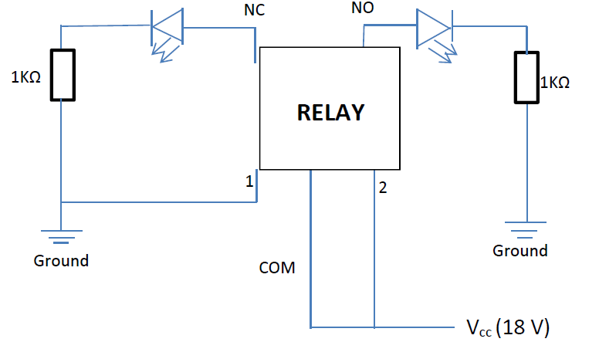

**II. Burglar Alarm**

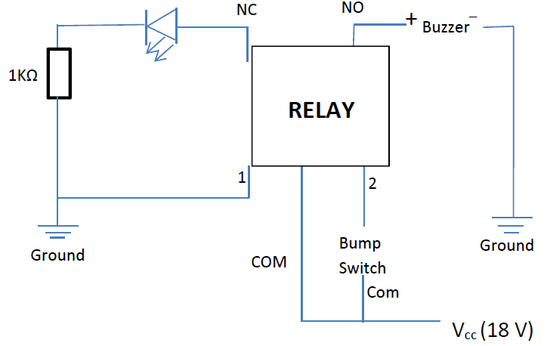

**III. Relay as an Oscillator**

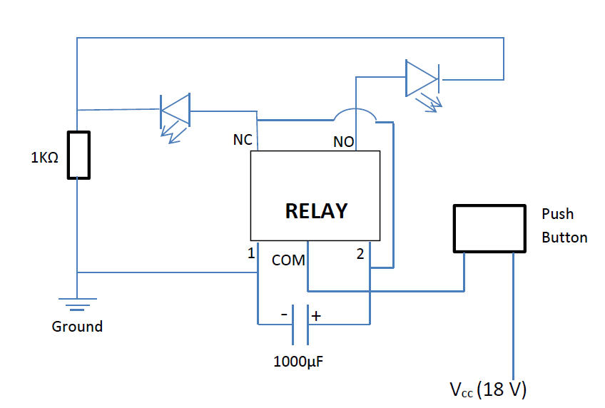

IV. **Touch Activated Switch using a Transistor**

